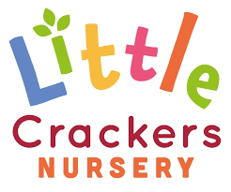 1st May 2020

**Weekly News**

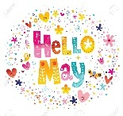

|  |  |  |
| --- | --- | --- |
|  | **A message from our Nursery Prefect, Martha Summers**  Heart Cute Love ClipartHi Everyone! It's Martha! I hope you are all well, and keeping busy at home. I've been going on lots of walks through the woods, that's where I am in the picture! There are lots of pretty bluebells in there, and I have seen lots of birds up in the trees. What have you been up to? I hope you are all back at nursery soon so I can see you, but I also hope you are having fun with your families. I can't wait to hear what you all have been up to! I miss you so much and can't wait to see you all soon! Lots of hugs, Martha.  C:\Users\locarrollbailey\AppData\Local\Microsoft\Windows\INetCache\Content.MSO\34F91740.tmp | |
| cid:3596181B-A2AB-4842-B7EA-2226D3B633FD-L0-001 cid:07aa9f1f-2f43-473a-919f-2486cacf5a07@GBRP265.PROD.OUTLOOK.COM cid:ddfa7f4d-a35e-425c-a55d-b74d73303826@GBRP265.PROD.OUTLOOK.COM cid:FE99EF58-4D54-48F9-A7D0-B06FF387F5B7-L0-001 | | |
| libraries from home  We'll Help You Get Started with Our [Digital Library](https://library.warwickshire.gov.uk/iguana/www.main.cls?surl=eBooks).  Warwickshire Library Services: look out for ways of borrowing stories without going out. | | You can find interactive books here to read online or watch with signing.  <https://www.booktrust.org.uk/books-and-reading/have-some-fun/storybooks-and-games/>  C:\Users\locarrollbailey\AppData\Local\Microsoft\Windows\INetCache\Content.MSO\4CA88A7A.tmp [Amazon Audible](https://stories.audible.com/start-listen) **Now streaming children’s books for free**  <https://stories.audible.com/discovery/enterprise-discovery-21122358011?ref=adbl_ent_anon_ds_ds_dccs_sbtp-0-1> |

Little Crackers Nursery · Crackley Hall · St Joseph’s Park · Kenilworth · CV8 2FT

Telephone: 01926 514444 · Fax: 01926 514455 · e-mail: littlecrackers@crackleyhall.co.uk

www.crackleyhall.co.uk

Registered Charity Number 1087124 Company limited by guarantee Number 4177718